Ho Chi Minh City University of Technology

COMPUTER NETWORK

LAB 3.2 Search form

Student: Nguyen Minh Hung – 2052504

Lecturer: TS. Nguyen Le Duy Lai

FACULTY of COMPUTER SCIENCE and COMPUTER ENGINEERING

*Ho Chi Minh City, November 2023*

**LAB 3.2 Search Form**3.2.1 Create a search form to search for specific products from the database.  
3.2.2 List all the products found from 3.2.1 or show a notification if no product is found

**Implement:**

1. **Search product by name**

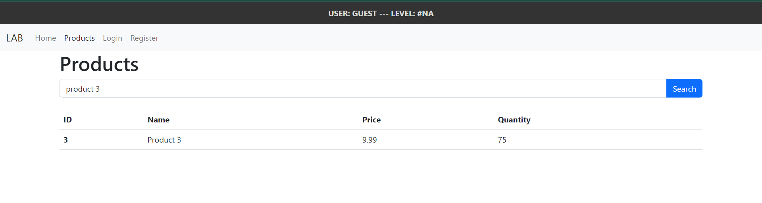

1. **Search product by ID**

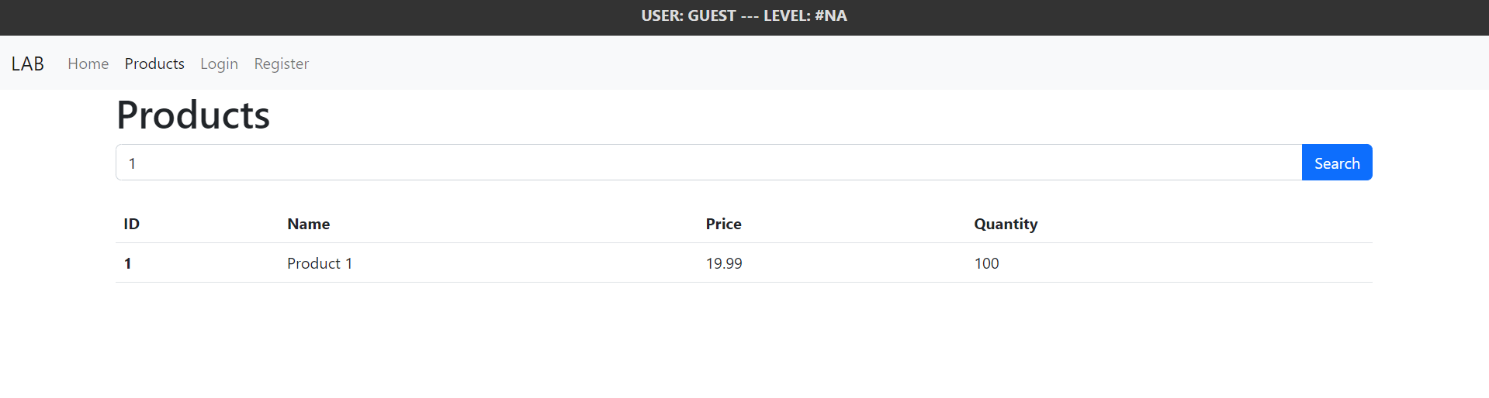

1. **Search products that share the same name**

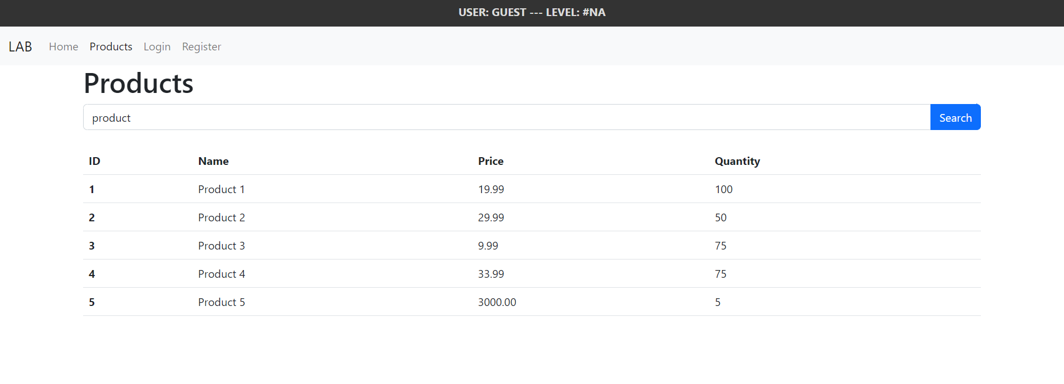

1. **Search product not found**

